Ethernet Repeater

🔁 What is an Ethernet Repeater?
# Source: Chatgpt (GPT‑5 Mini) at [12/18/2025]
An Ethernet Repeater is a Layer 1 (Physical Layer) network device used to extend the distance over which Ethernet signals can travel by regenerating and amplifying them. It allows data to continue beyond the 100-meter limit of standard Ethernet cables (Cat5e/Cat6).
✅ It acts like a "signal booster" for Ethernet — but does not analyze or filter the data.

🧱 Why Is It Needed?
# Source: Chatgpt (GPT‑5 Mini) at [12/18/2025]
Standard Ethernet (especially Fast Ethernet or Gigabit Ethernet) has a maximum cable length of 100 meters (328 feet). After that, the electrical signal becomes too weak or distorted.
An Ethernet Repeater sits between two segments to restore the signal, allowing you to:
- Extend cable runs beyond 100m
- Connect distant devices like IP cameras or switches
- Preserve signal quality without losing data

🖥️ Example Setup
# Source: Chatgpt (GPT‑5 Mini) at [12/18/2025]

[Switch]───100m───[Ethernet Repeater]───100m───[PC/Camera]

- Without the repeater, the second 100m cable would not work reliably.
- The repeater boosts and forwards the signal exactly as it was.

🔧 Key Features
# Source: Chatgpt (GPT‑5 Mini) at [12/18/2025]


Feature | Description
Layer | OSI Layer 1 (Physical)
Forwarding Logic | No logic — forwards all bits
MAC Awareness | ❌ No (unlike switch/bridge)
Duplex Support | Half or full, depending on design
Power | May require power (PoE repeaters exist)

🆚 Ethernet Repeater vs Switch
# Source: Chatgpt (GPT‑5 Mini) at [12/18/2025]
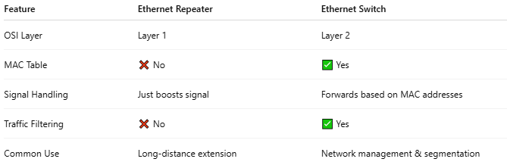

Feature | Ethernet Repeater | Ethernet Switch
OSI Layer | Layer 1 | Layer 2
MAC Table | ❌ No | ✅ Yes
Signal Handling | Just boosts signal | Forwards based on MAC addresses
Traffic Filtering | ❌ No | ✅ Yes
Common Use | Long-distance extension | Network management & segmentation

✅ Pros
# Source: Chatgpt (GPT‑5 Mini) at [12/18/2025]
- ✅ Simple to use
- ✅ Extends Ethernet over long distances
- ✅ No configuration needed
- ✅ Often powered by PoE (Power over Ethernet)

❌ Cons
# Source: Chatgpt (GPT‑5 Mini) at [12/18/2025]
- ❌ No intelligence (forwards everything)
- ❌ Can’t manage traffic or prioritize data
- ❌ Only helps with Layer 1 problems (signal, distance)

📌 Summary
# Source: Chatgpt (GPT‑5 Mini) at [12/18/2025]
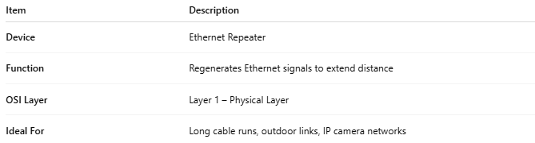

Item | Description
Device | Ethernet Repeater
Function | Regenerates Ethernet signals to extend distance
OSI Layer | Layer 1 – Physical Layer
Ideal For | Long cable runs, outdoor links, IP camera networks

